试用版授权激活方法
The method to activate trial license

工程路径：打开Twincat3的工程文件C:\Users\sim_demo\EAP\ SimulatorRecv.sln
Project path: C:\Users\sim_demo\EAP\ SimulatorRecv.sln
- 在此 TwinCAT3 开发环境中手动激活 7 天试用授权，具体步骤如下： 点击 system 下的 license，选择对应的License TC1000，TC1100，TC1200
- To activate the 7-day trial authorization in the TwinCAT3 development environment, perform the following steps: Click the license in system，choose TC1000，TC1100，TC1200
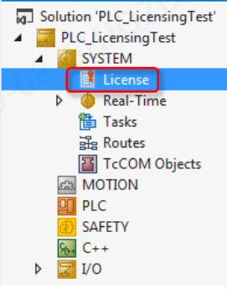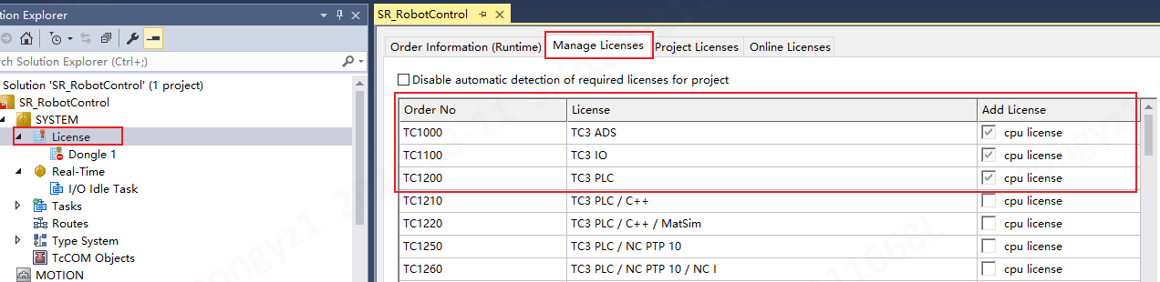
- 注意选择“Target Hardware id”点击 Activate 7 Days Trial License，随后会 弹出验证码方框，输入 5 位验证码，大小写有区分
- Select "Target Hardware id" and click Activate “7 Days Trial License”. The verification code box will pop up. Enter a 5-digit verification code, case sensitive
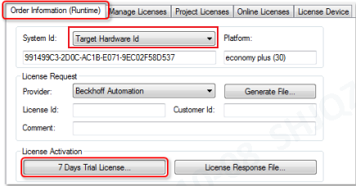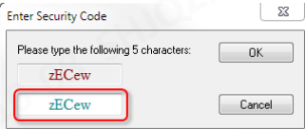

- 输入正确后点击 OK 会弹出窗口告知 7 天的试用版 license 已经生成，这样 我们就可以有 7 天的授权可以用，如果过期了再次用同样的方法激活就可以了
- If you enter the correct information and click OK, a pop-up window will be displayed to inform us that the 7-day trial license has been generated. In this way, we can use the 7-day license. If the license expires, we can activate it again in the same way

- 在License和about Twincat中都可以看到授权到期的时间；
- You can check the expiration time of the License In “about Twincat”.
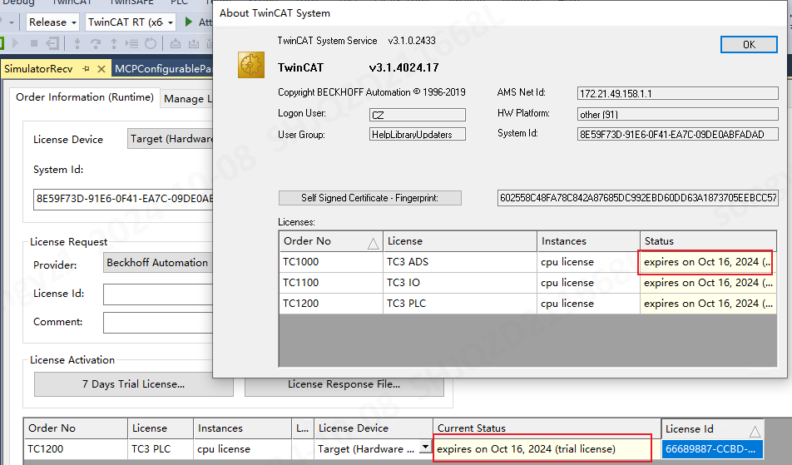

- 激活完成后重启模拟器背包和医生台车
- Restart the simulator and Doctor Console cart after activation

